Copyrights 2
1. Overview 2
1.1.1 GENIUS G840 Characteristics 2
1.2 System Requirements 3
1.3 Programmer Package 4
2. Install the Software 4
2.1 Setup G540(or G840) Software 4
2.2 Install USB Driver 7
3. Quick Guide 10
3.1 Description of User Interface *(UI) 10
3.1.1 Main menu and Toolbar 11
3.1.2 Information window 12
3.1.3 Data buffer 12
3.2 Operation Intro 13
3.2 1、On_Line (means connect the hardwar to PC): 13
3.2.2 The off-line operation (Only G840) 14
4. Expatiation 15
4.1 Base Operation 15
4.1.1 Select Device 15
4.1.2 Load File 16
4.1.3 Set Encryption . 18
4.1.4 Insert device 18
4.1.5 Program 19
4.1.6 Erase 20
4.1.7 Blabk 21
4.1.8 Verify 21
4.1.9 Encrypt 21
4.3 The Brief Introduction of support device 21
4.4 About power source adapter 22
4.5 IC Test 23
4.5.1 Test known Device 23
4.5.2 Tests the unknown Device 24

Copyrights
Software Copyright 2008——0101 STAGER
User’s Manual Copyright 2008——0101 STAGER

The distribution and sales of the product are intented for use by the original purchaser under the terms of the License Agreement. This document
may not, in whole or part, be copied, Photocapied, reproduced, translated or reduced to any electrowic medium of machine-readable from without prior
consent in writing from STAGER.

1. Overview

Genius GXXX serie productions lineup:
GENIS G540 universal programmer:USB communication,40 pins locking socket, Updatable by software.Powerde by USB .Contour: 143mm×112 mm×25 mm.
GENIUS G840 universal programmer:USB communication,40 pins locking socket,Full Pin_Drived, Off_line Operation,Updatable by software.Powerde by 5V1000MA powersupply Contour: 143mm×112 mm×25 mm）

1.1.1 GENIUS G840 Characteristics
GENIUS G840 is a newst type of the GENIUS programmer family. It has the features as following except the usual performances of others.

1. 40 pins Locking Socket.Full Pins Drived .
2. Updateable by software. The users enjoy the lifelong updating support.It need only to download the newst software from our net site to complete the update. (Please login to: http://www.sta51.com )
3. On-line operation and off-line operation fuctions. It is both suitable to the development, the testing, the teaching, and suitable to the batch programming.
4. Touch key. You may not need to click on the mouse, which causes the operation to be more convenient. The touch key is durable and be never damaged.
5. Pin Contacting detection. In the cases of poor conect between the IC and the sockt or wrog puting, the informations will be detected and the operation will be broken.
6. Triply indicats the operating result: displaied in the window, in the LED lamp and choseable buzzing.
7.Powver supply: 5V1000mA.Low Power consumption(<200mA) so as to avouch Non Over heat.
8. Perfect defenses. That both refrain effectively from to damage user device and protect itself.
9. The pocket-sized and compact outward, provides a good visual effect and a convenient carries.

Also, GENIUS G540 is a newst type of the GENIUS programmer family.
It has the features.

1. 40 pins Locking Socket.
2. Updateable by software. The users regale the lifelong updating support.It need only to download the newst software from our net site to complete the update. (Please login to: http://www.sta51.com )
3. Pin Contacting detection. In the cases of poor conect between the IC and the sockt or error place, the informations will be detected and the operation will be broken.
4. LED indicator.
5.Powvered by BUS .Low Power consumption(<200mA) avouch Non Over heat.
6. Perfect defenses. That both avoid effectively to damage user device and protect itself.
7. The pocket-sized and compact outward, provides a good visual effect and a convenient carries.

1.2 System Requirements

The minimum requirements are as follows:
A personal computer with one USB port , CD-ROM driver windows NT/2000/XP/Vista operating system, There are least 100M of spare space on the Hard disk

1.3 Programmer Package

Standard package contains the following:
Main body of programmer 1 pcs
USB connecting cable 1 pcs
AC/DC adapter (Only G840) 1 pcs
The installation software CD 1 pcs
User’s Manul 1 pcs
Registration card 1 pcs

2. Install the Software

If it's your first time to use the USB-based programmer of Genius Gxxx, This chapter will help you to install the software and to connect the hardware.
There are tow parts will be installed:G540(or G840) Software & USB Diver.
USB device is PnP device. The USB Driver must be installed before the device can be used.At first.time installation, windowns will start with “new hardware wizard” to scan all available INF files and find out the appropriate USB Driver

2.1 Setup G540(or G840) Software

1. First of all, insert the CD into CD-ROM driver.
2.Double click the G540Setup(or G840Setup) in the foldr “SetupFile” to run it.The following window be showed:

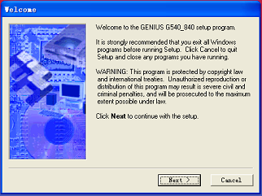

Figu 1

Click the button“Next”,The window is changing as:

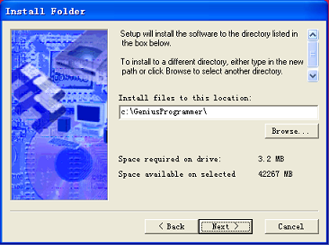

Figu 2

Now, you can chang the destination folder if you want to do.Then click the button “Next”.The widow is changing as following:

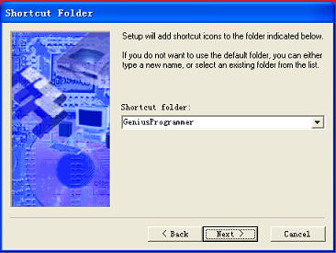

Figu 3

Click the “Next” again to go on

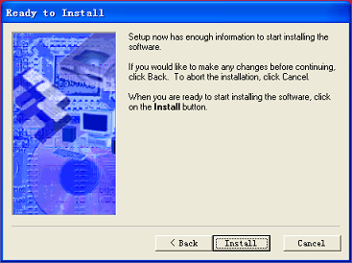

Figu 4
Please read the text carefully，click button "Install"

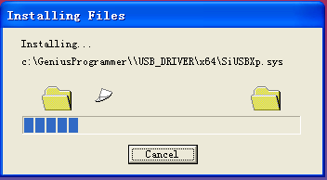

Figu5

The files are copying.After this process,it will display followiong information:
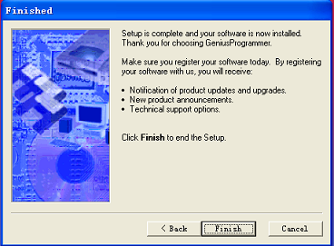

Figu 6

Click button “Finish” to finish the setup.

The Shartcut Icon of G540 (or G840) was created on the desk of the PC

2.2 Install USB Driver
The installation of the USB Driver contains tow steps:one is per-installing and anather is connecting USB device
Step 1:Pre-inteall the USB Driver. This step is in oder to copy automatically all files of the Driver to PC.
Double Click to run the StgICproUSB_Installer.exe at the folder USB_DRIVER of the DISK.The window as following:

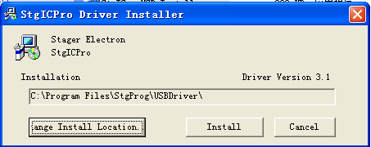

Figu 7

You can chang the Installing location if it is necessarily.
Then click the botton “Install”.
It showing:

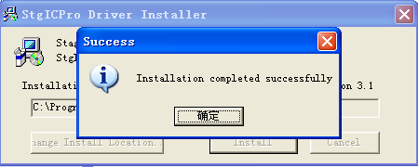

Figu 8

Click the button “OK”.Finish Step 1.

Step 2 Connect the USB device. This step connect the USB device to the pc and install the specific files to Widows system automatically.
Connect the Programmer main body to PC’s USB interface.The LED lamp light.(if it is G840, the power must be turn on).The PC is scaning the new USB device and is showing the window.(note: her use chinese version window for example.)

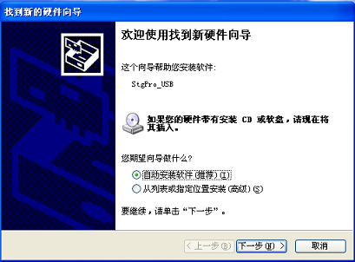

Figu 9

Select the automatically then click the button “Next”.The window changes:

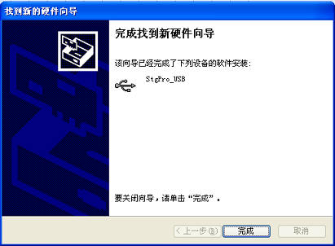

Figu10

Click the button Finish to finish the installation

3. Quick Guide

This chapter helps users understand the process of IC programing.

3.1 Description of User Interface *(UI)
The hardware must be connected with PC befor run the soft ware.
Double click the shartcut Icon of the G540 (or G840) on the PC desk to run it. The UI appears user
(F21)

Main menu单
Tool bar
Information window

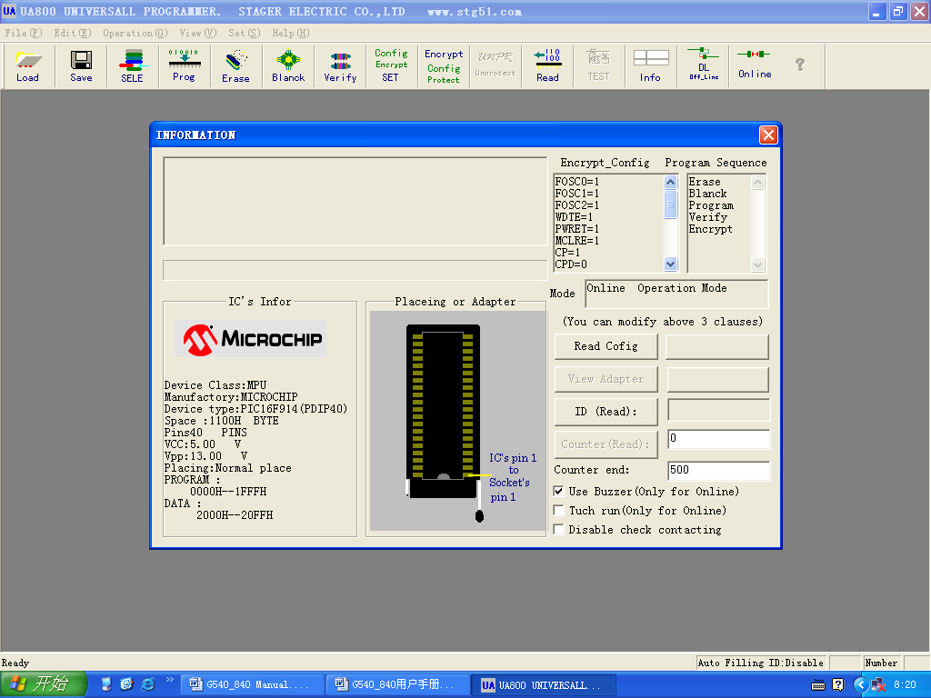

Figu 11

3.1.1 Main menu and Toolbar
Same as general Windowns software, any operation of G540(or G840) can be executed on the main menu or the toolbar.
The main menu of G540(or G840)includ File, Edit, Operation, View, Set,Help.The toolbar includs the functions often used, they are Load,Edit,Select,Progrmming,Eras, Block check,Verify, .…...

3.1.2 Information window
The Information window is used to demonstrate the IC information , programming environment and operating results
(F22)
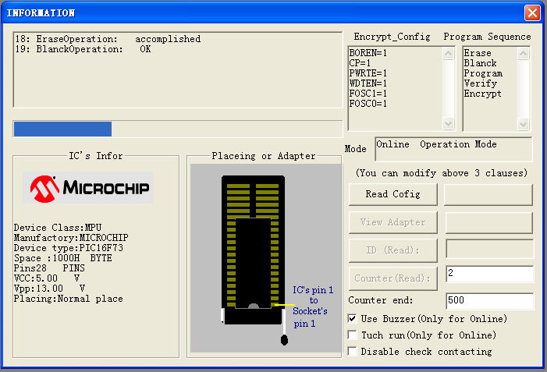

Figu 12

3.1.3 Data buffer
f23

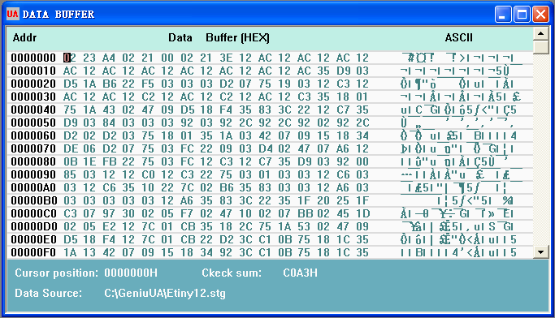

Figu 13
This window demonstrates the data of the PC data buffers. The demonstration formation may be either Hexadecimal(HEX) or JED. The buffer data may be gotten from one of three methods,that is Loading the file ,Reading the device or Editing the data buffer. The Data Buffer window is close when start the G540. and it will automatically display after you load file,read from device,or fill the data buffer.

3.2 Operation Intro

3.2 1、On_Line (means connect the hardwar to PC):
Click the button SELE on the toolbar .Select Device lass,Manufactory,Device according to the target device.
2、Load data:
If your datas are at the data file, click the button Load on the toolbar . Locate to your data file then open it .
Note: Must select the formation to match the formation of the file.
If your datas are in the sample device,please place the sample device into the locking socket then click the button Read on the toolbar.This operation read the device data to the buffer.
3、Set Encryption or Configuration value.
Click the button Config Encrypt SET. to set Encryption or Configuration parameter according to the device attribute.
Note: The seting values take effect after Encrypt operation
Some of device may has not the encrypting feature.
4、Set Programming Operation Sequence
There is a default Programming Operation Sequence for each device selection . Generally it is not necessarly to chang.If you want to chang it,you can click main menu Set—Set Programming Sequence .
5、Place the target device on the locking socket
6、Click the button.Prog on the toolbar, the Programming Operation Sequence be set at step 4 are automaticaly orderly executing
7、Replay 5, 6, to program anather device.

3.2.2 The off-line operation (Only G840)
The Off_Line Operation means that the Programmer run solely without cennected to PC.The informations are needed download to the programmer hardware befor Off_Line operation.
After do the steps 1 to 4 in the section 3.2,click the button DL Off_Line in the toolbar to download the informations and to break the logic connection.
Aftertime,you can use it without connecting the programmerto PC.
Refer to section 4 for detaill.

4. Expatiation
After you read the Quick Guide, this chapter will tell you all the funcitions of the programmer.

4.1 Base Operation
GENIUS G540’s operations can be executedr by the main menu or the toolbar. The oprations may mostly be completed by one-click, but some time may need multi- steps.

4.1.1 Select Device
Click button “SELE” (toolbar), display the Select Device windown.( )
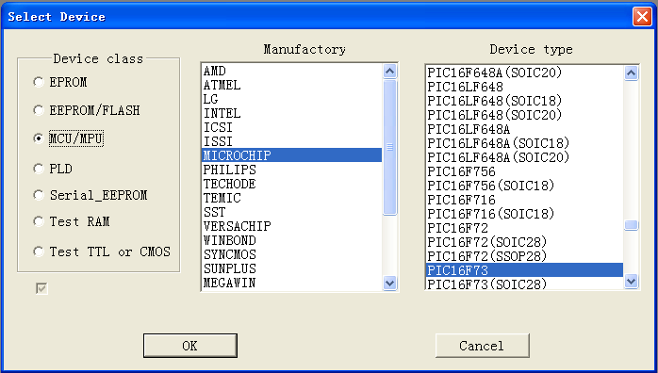
Figu 14

Please select the Device class ,Manufactory ,and Device type according to the attribute of the target device.
We recommend that you use as far as possible the selection matching with the target device.

4.1.2 Load File
The Load File load the data from the data file into data buffer of the G540(or G840).
Click button Load (toolbar), the Open file dialog box will be display.

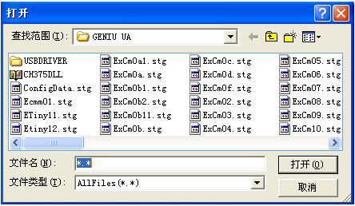

Fogu 15

Locat to your data file location ,double-click the file name or click the button Open, the window is closing, at the same time, the File loadding mode window will show.
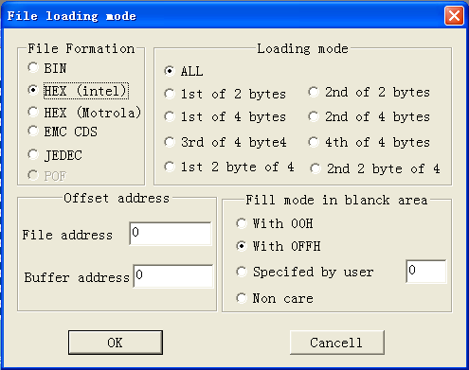

Figu 16
Please select the File Formation.It is must matching to the formation of your data file.
It is often not necessarly to chang the Offset address,the Loading mode and the Fill mode in blank area.
Click button OK,that will close dialog box.The Data Buffer widow display automaticaly.
For memory(include EPROM,EEPROM,FLASH,Serial_EEPROM) or MCU,the data formations may be HEX or Bin. For the PLD the data formation is only JED.
The file that is HEX or JED formation be created by specific assembler.
You can chang the File offset address or Buffer offset address to load the data of the file to different location of the data buffer.The dfault offset addresses are 0.
Fill mode in blank area can be With xxH,or non care it ,her xxH is any value.The default value is 0FFH.
You can connect tow or more files if you use the Offset address and Fill mode in blank area.For a example: connect file a.hex and b.hex. first, you can load the file a.hex with Datauffer offset address 0 and Fill value 0FFH,then load the file b.hex with Data buffer offset address xxxxH and Non care Fill mode.her the xxxxH is the end address of the file a.hex.

4.1.3 Set Encryption .
After you selected a new type device that it need to encrypt or need to config,you must set the encryption paramters.
Click the butoon Config Encrypt SET on the toolbar.It will show the following window.(This window is for PIC16F73.It may be diferent for different device)
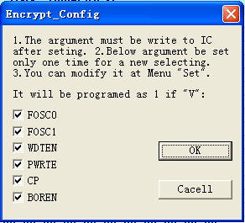

Figu17

Set the parameters.then click button OK to close the window.
Note: The seting values must be written to the device by Encrypt operation

4.1.4 Insert device
When you selected a type of device to program,the inserting mathod of the device was ascertained It is shown with diagram.Rafer to Figu 12
Put the target device into the locking socket and lock it.

Note: Don’t insert the device before turn on the power, and don’t take out the device after turn off the power, so as to prevent the wrong operation from unstable period of ON/OFF power.

4.1.5 Program
The programming operation is a combination of multi-opernations.These operations are repetitive used .
The operation sequence of programming are created when start the G540 or select a new type of device.You can rearrange the sequnce if it is necessarly

1. Rearrange Sequnce of Programming
Click “Set Programing Operation Seunce”at main menu，and pop up a dialog box of “Programing Operation Seunce”.The options will appear on the left column of the dialog box, and selected items will appear on the right. The selected items will be orderly executed by pressing the Prog utton.on the toolbar
Select an option on the left, and press the button “ADD”，or double click the item， then this item will be added to right. If you need the same item, you can add more. Contrarily, select an item on the right column, press button“Delete X”, or double click the item bar, and this item will be deleted.

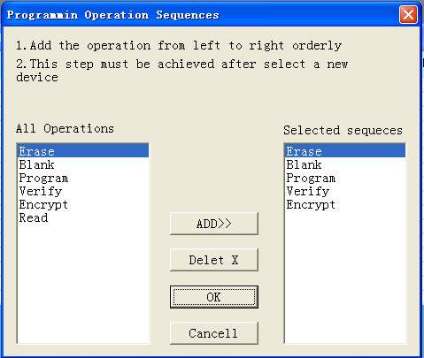

Figu 18
2. Programing
Click the button Prog on the toolbar.The operation sequnce are oerderly executed

Replay 4.1.4 & 4.1.5 2 to program anather devices

The buttons “Erase” “Blank” “Verify” “Encrypt” … on the toolbar can be executed step by step when it is necessarly

4.1.6 Erase
For EPROM type, it demands that we erase it by using ultra-violet eraser. For the type of EEPROM, FLASH ect, we can accomplish it on this programmer. Click the “Erase” bottom in the toolbar, complete the erase at once.

4.1.7 Blabk
Click the button “Blank” in the toolbar, the blank operation will excute

4.1.8 Verify
The operation is compare the content of the Programmed evice to the content of data buffer， so as to confirm the Program whether correct. The verify operation should be done before encrypt! We just need to click the button “Verify” on the toolbar， the result will be displayed in the information window.

4.1.9 Encrypt
The Encryption parameters must be set befor encrypting if the device selection is newst Refoer to section 4.1.3
Click the button Encrypt in the toolbar ….

4.3 The Brief Introduction of support device

Following is only the brief introduction of support device.Refer to file DeviceList_G540(DeviceList_G840) on the Disk for detail.
1. EPROM（ultra-violet erase memory）：all big brands'EPROM，in clyding:2716、27C16、2732、27C32、2764、27C64、27128、27C128、27256、27C256、27C512、27C010、27C040 etc.
2. EEPROM and Flash（electric erase memory）：2816、28C16、2817、28C17、28C64、28C256、28C010、28F512、28F010、28F020、29C256、29C512、29C010、29C020、39SF256、39SF512、39SF010、39SF020、39SF040 and 49...
3. MPU(micro controller)
The 51 series micro controller mainly using：
ATMEL：AT89C51/52/55WD/LV55、AT89S51/52/53/、AT89C1051/2051/4051、AT90S1200/2313/、Attiny11/12/15
Winbond：77E58/78E51/78E52/78E54/78E58/78E516/...
AMD：87C51/87C521/87C541
LG：GMS97C2051/97C54/97C58/97C2051/97C4051/
INTEL：87C51~87C58、87C5FA~FC、87C51RA~RT...
SST：SST89C54/58、89F54/58...
The other brands' 51 series micro controller ：
PIC series micro controller ：
Micvochip PIC12C508/509、PIC16C502、16C52/54/55/57/58、PIC16C61/62/620/621/622/623/624/625、PIC16C63、PIC16C64/65/67、PIC16C73、PIC16C74/76/77、PIC16C745/765、PIC16F72/73/74/76/77、PIC16F870/871/872/873/874/876/877/877A/84PCF745/746
MDT series MDT2005 etc.
PLD（programmble gate array）：main include：
ATMEL：AT16V8、AT20V8、AT22V10、ATF16V8、ATF20V8、ATF22V10 etc.
LADICE：GAL16V8、GAL20V8、GAL22V10 etc.

4.4 About power source adapter

Genius UA800 universal programmer（USB communication）
1、Under the on-line pattern may use the USB power supply, generally do
not have to use the power source adapter to supply power. When USB
power supply ability insufficiency may use the power source adapter to
supply.
2、Under the off-line pattern uses the power source adapter power supply,
uses AC110 - 240V, DC6V1000mA (center, outer annulus negative)

Genius SU0640 universal programmer（USB communication）
Uses the USB direct power supply, does not need the external power
supply
Genius SP2006 universal programmer（serial communication）
The use power source adapter power supply, uses AC110 - 240V, DC5V1000mA (center, outer annulus negative)

4.5 IC Test
The function of IC test mainly is aims at the RAM component, TTL (the 74LS series, the 54LS series), the CMOS4000 series general digital circuit says.
IC Test have two situations：
1、Known it’s modle, test it whether is in good condition or has broken;
2、Unknown it’s modle, search and analyze which modle it is belonged.

4.5.1 Test known Device
The component put in the locking socket lock it , then click the tool bar "Select" key, Selec" RAM test" or "test TTL or CMOS" ,Show the dialog box:
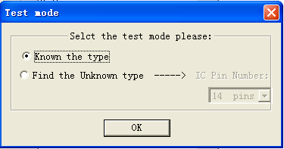

Figu 19
Clicks on " Test known" button, that will spring the dialog box of choice component.

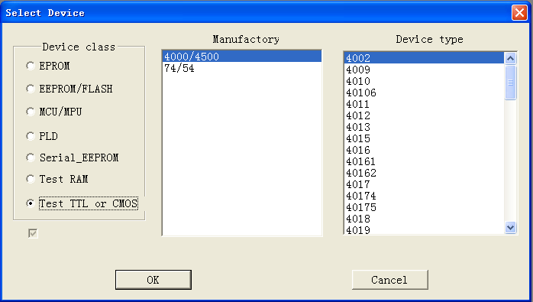

Figu 20
Please select the divice that is as the same as the target device clicks OK button to close the window.Put the target device into the socket Click the button Test on the tool bar, the system starts to test the device, and the result will demonstrate in the information

4.5.2 Tests the unknown Device
See the Figu 18 and select the Find the Unknown type,the window changes as following:
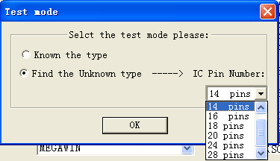

Figu 21

Please select the IC Pin Number same as the number of the target device. Put the target device into socket then click the Test button on tool bar. result will demonstrate as following:
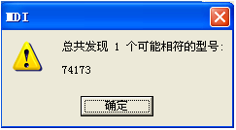

Appendices

License Agreement
The copyright of the program and user's guider remain the property of STZGER.

you may:
Copy the program for back-up purposes ONLY in support of its use on a single computer.
Transfer the program and license to another party if the other party agrees to accept the terms and conditions of this agreement.
you may not:
Use this produet in a computer system or network, which allows the program to be operated by more than one user at a time.
Modify, copy, or transfer the user's Guide, other documentation or any copy.
Reverse engineering, de-compiling, or disassemkble any program module or security device.

Customer Support
Congratulate on you have Genius series program machine. you had been a friend of stager Electric CD.LTD for all time.
Keep good your purchase credential, you will get favorable affer service and preferential treatment:
If meet software update, you will have fruition right for free.
Supply corresponding technique service.
Guarantee to keep it in good repair for half a yesr for free, and supply service for life.
you can take 80% of market value to buy any other production of Genius series.
Software updates are available free from the web site.
Http://www.stg51.com
The telephone of technique service is ：+86（0755）82528167
E-mail：stgxiao@163.com
fax: 0755-82526062

